Juliette Joseph-Odogbo
Linux Administration
11/16/2025
Networking Assignment

Purpose of the Assignment
The purpose of this assignment is to document how I configured and verified networking on both CentOS and Ubuntu servers. This includes checking defaults, installing required tools, setting a static IP and DNS, confirming connectivity using essential commands, running network scripts, and providing clear screenshots showing each step. These steps will help a beginner going through networking settings on their server
CENTOS SERVER DOCUMENTATION
Date Performed: November 7, 2025
How Networking Works by Default on CentOS
CentOS uses NetworkManager as its default networking system. NetworkManager automatically receives an IP address through DHCP and manages DNS, routing, and interface settings without manual configuration. Its main files are stored in /etc/NetworkManager/, and connection profiles are saved in /etc/NetworkManager/system-connections/. DNS is controlled through /etc/resolv.conf, and routing information can be viewed with ip route. This means CentOS is fully network-ready immediately after installation unless a static IP address is required.

Default Networking on CentOS (Before Changes)
CentOS uses NetworkManager + DHCP by default.
Default Files
Purpose | Location
Interface config | /etc/sysconfig/network-scripts/ifcfg-enp0s3
DNS info | /etc/resolv.conf
Hosts | /etc/hosts
Hostname | /etc/hostname
Default Commands
Task | Command
View connections | nmcli con show
View IP | ip addr
View routes | ip route
Screenshot : nmcli con show
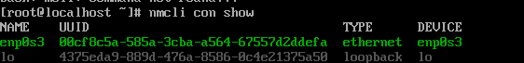

2. Install & Update Networking Tools (CentOS)
Commands:
sudo dnf upgrade -y
sudo dnf install net-tools traceroute tcpdump -y
Screenshot : dnf “Complete!”
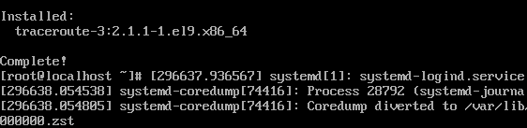
Screenshot : ifconfig works
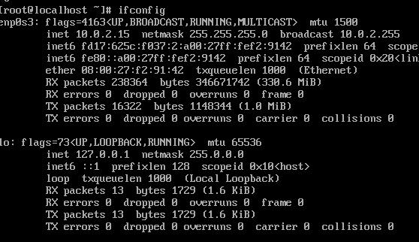
Screenshot : traceroute output
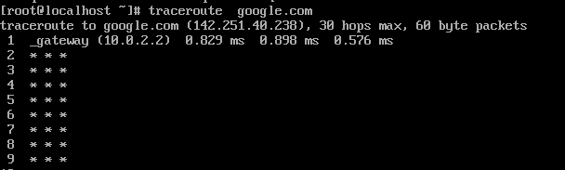

Screenshot : tcpdump -D
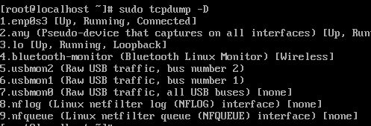

3. Verify Internet Connectivity (CentOS)
Commands:
ip addr
ping -c 3 google.com
ping -c 3 8.8.8.8
Screenshot : ip addr and Screenshot : ping success
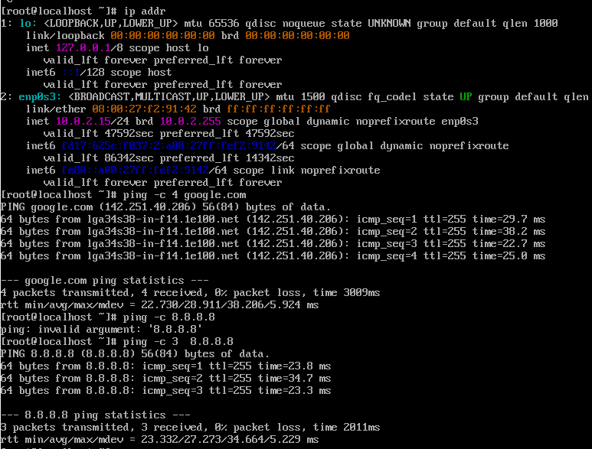

4. Change From DHCP → Static IP (CentOS)
Command:
sudo nmcli con mod "enp0s3" ipv4.method manual \
ipv4.addresses 10.0.2.20/24 ipv4.gateway 10.0.2.2 \
ipv4.dns "8.8.8.8" autoconnect yes
Screenshot : nmcli modification successful
Activate:
sudo nmcli con up "enp0s3"
Screenshot : “Connection successfully activated”
Restart:
sudo systemctl restart NetworkManager
systemctl status NetworkManager
Screenshot : (running)
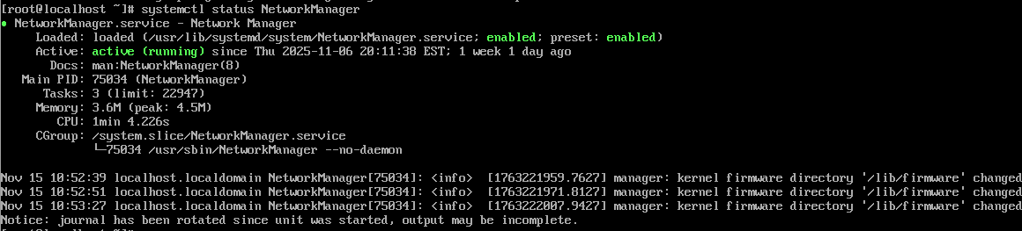

5. Verification (CentOS After Changes)
Commands:
ip addr
ip route
nmcli dev show | grep -i dns
ping -c 3 google.com
Screenshot = 10.0.2.20
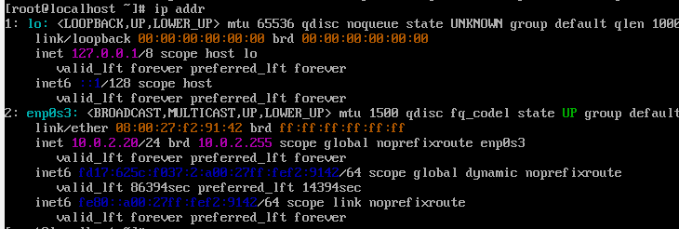
Screenshot: gateway 10.0.2.2
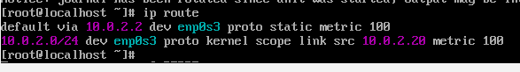
Screenshot : DNS = 8.8.8.8
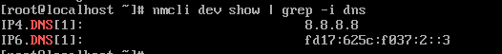
Screenshot : ping success
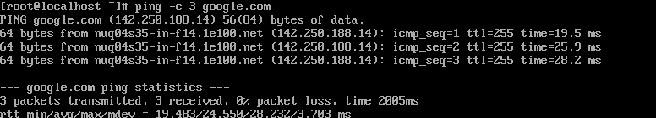

SECTION 2 — UBUNTU SERVER DOCUMENTATION
Date Performed: November 8, 2025

How Networking Works by Default on Ubuntu
Ubuntu Server uses Netplan for its networking configuration. Netplan reads YAML files stored in /etc/netplan/ and applies them using systemd-networkd. By default, the config contains dhcp4: true, meaning Ubuntu receives its IP address automatically from DHCP. DNS is handled through systemd-resolved, which uses the stub resolver 127.0.0.53, visible inside /etc/resolv.conf. This default setup allows Ubuntu to connect to the internet immediately after installation unless a static IP is needed.

Default Networking on Ubuntu (Before Changes)
Ubuntu uses:
- Netplan
- systemd-networkd
- DHCP enabled
Default Config Files
Purpose Location
Netplan config /etc/netplan/00-installer-config-yaml
DNS resolver /etc/resolv.conf
Hosts /etc/hosts
Hostname /etc/hostname
Screenshot : ip addr
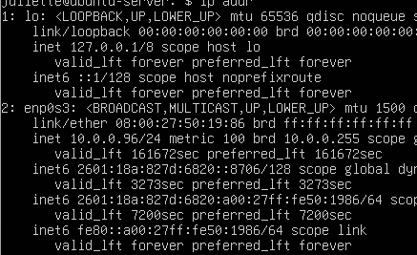
2. Install & Update Tools (Ubuntu)
Commands:
sudo apt update && sudo apt upgrade -y
sudo apt install net-tools traceroute tcpdump -y
Screenshot : apt update
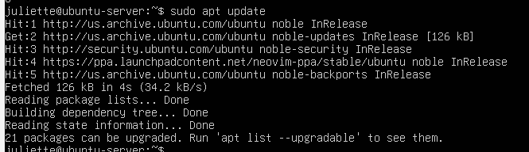
Screenshot : install finished
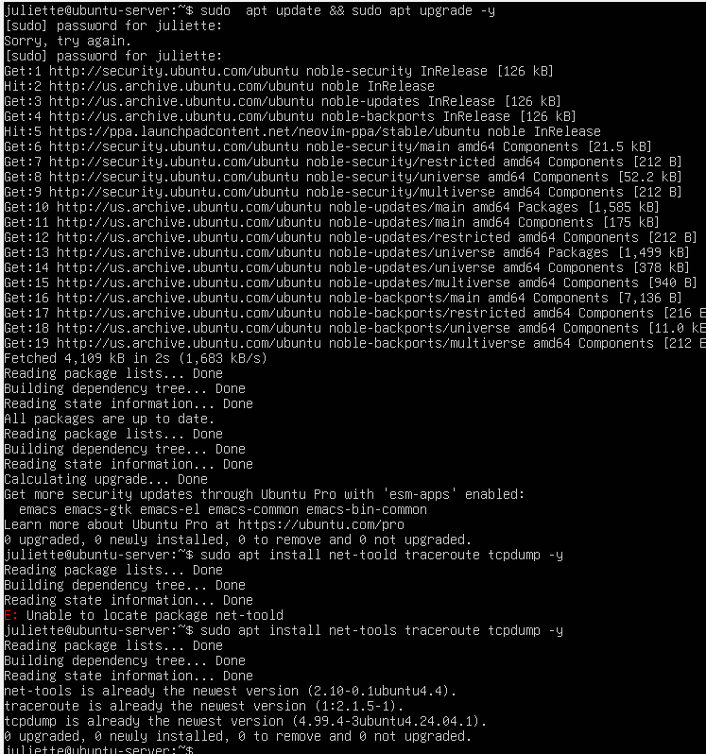
Screenshot : ifconfig output
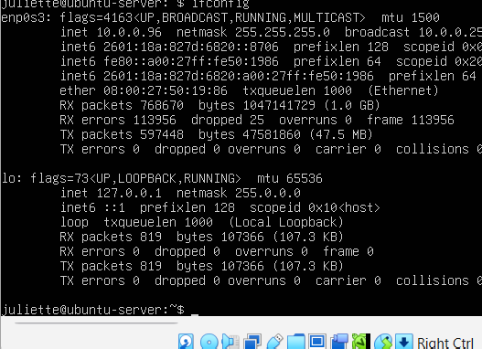
Screenshot : traceroute output
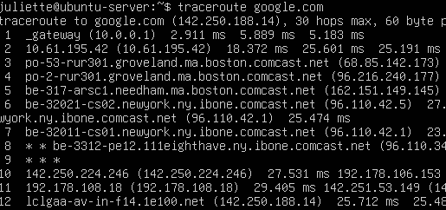
3. Install NetworkManager (Ubuntu)
Commands:
sudo apt install network-manager -y
sudo systemctl restart NetworkManager
sudo systemctl enable NetworkManager
systemctl status NetworkManager
Screenshot : installation
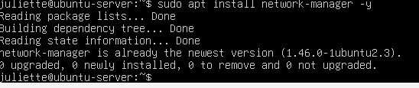
Screenshot : active (running)
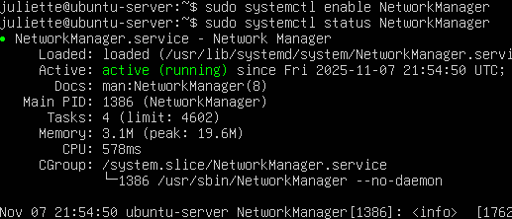

4. Switch Netplan → NetworkManager
sudo nano /etc/netplan/00-installer-config.yaml
Replace with:
network:
version: 2
renderer: NetworkManager
ethernets:
enp0s3:
dhcp4: no
addresses: [10.0.2.30/24]
gateway4: 10.0.2.2
nameservers:
addresses: [8.8.8.8, 1.1.1.1]
Apply:
sudo netplan apply
Screenshot : YAML file
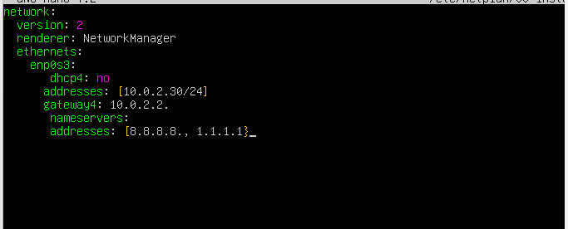
Screenshot : netplan apply
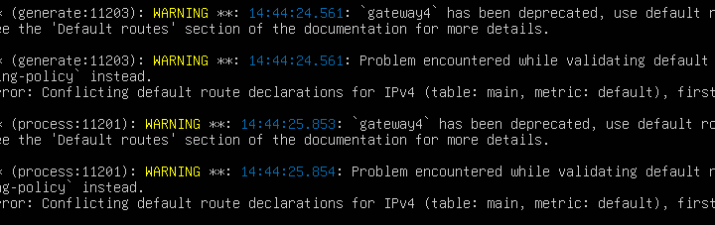
When I ran sudo netplan apply, Ubuntu showed a warning that gateway4 is deprecated and that there were conflicting default routes. This happened because both Netplan and NetworkManager were trying to set the default gateway. Even with the warning, my static IP (10.0.2.30), gateway (10.0.2.2), and DNS still worked correctly, so I kept this configuration

5. Identify Connection Name
nmcli con show
Expected:
netplan-enp0s3
Screenshot : connection name
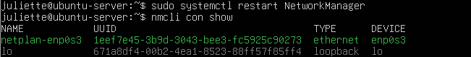

6. Apply Static IP (Ubuntu)
Command:
sudo nmcli con mod "netplan-enp0s3" ipv4.method manual \
ipv4.addresses 10.0.2.30/24 ipv4.gateway 10.0.2.2 \
ipv4.dns "8.8.8.8" autoconnect yes
Screenshot U11: successful command
Activate:
sudo nmcli con up "netplan-enp0s3"
Screenshot U12: “Connection successfully activated”
Restart:
sudo systemctl restart NetworkManager
7. Verification (Ubuntu After Changes)
Commands:
ip addr
ip route
cat /etc/resolv.conf
nmcli dev show | grep -i dns
ping -c 3 google.com
Screenshot : static IP = 10.0.2.30
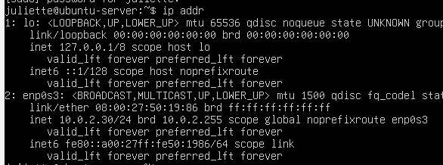
Screenshot : gateway = 10.0.2.2
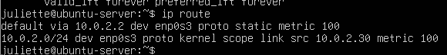
Screenshot : resolv.conf DNS
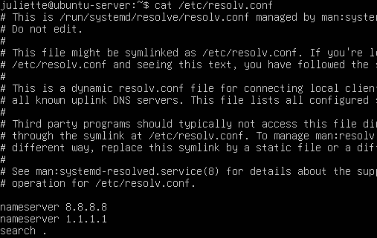
Screenshot : nmcli DNS
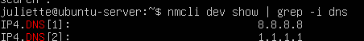
Screenshot : ping success
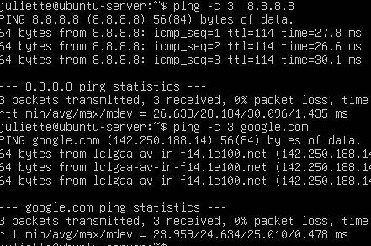

SECTION: How to Find All Relevant Information, Scripts, Configs, and Tools
How to Find All Required Network Information on CentOS
Purpose | Command / Location
View IP addresses | ip addr
View routing table | ip route
View DNS | cat /etc/resolv.conf
View connections | nmcli con show
View system logs | journalctl -u NetworkManager
View connection profiles | /etc/NetworkManager/system-connections/
Network interface file (legacy) | /etc/sysconfig/network-scripts/

How to Find All Required Network Information on Ubuntu
Purpose | Command / Location
View IP addresses | ip addr
View routing | ip route
View DNS | cat /etc/resolv.conf
Netplan config | /etc/netplan/00-installer-config.yaml
Restart network | sudo systemctl restart NetworkManager
View connection profile | /etc/NetworkManager/system-connections/
Check DNS service | systemctl status systemd-resolved

Tools Used (Both Servers)
Tool | Purpose
ip addr | Shows all interfaces & Ips
ip route | Shows routing and gateway
Nmcli | View & modify network connections
Tcpdump | Capture packets
Traceroute | Show network path
Ping | Test connectivity
Hostname | Identify the server

NETWORK DUMP AND TROUBLESHOOTING SCRIPTS
The purpose of these scripts is to quickly collect all important network information from a server and save it into one organized report file; also provide basic troubleshooting tips for someone who has no knowledge of networking using Linux servers . This helps with troubleshooting, documentation, and verification on both Ubuntu and CentOS. Instead of typing many separate commands, the script automatically gathers the hostname, IP addresses, routing table, DNS settings, network interfaces, and basic connectivity tests, and stores them in one place for easy review.

HOW TO RUN THE NETWORK DUMP SCRIPT (Both Servers)
The network dump script is saved in the home directory on each server:
- Ubuntu: /home/juliette/net_dump_basic.sh
- CentOS: /root/net_dump_basic.sh
The script automatically creates a folder called net-reports and saves the output file inside:
- Ubuntu → /home/juliette/net-reports/
- CentOS → /root/net-reports/

STEP 1 — Navigate to the Script Location
Ubuntu
cd /home/juliette
ls -l
CentOS
cd /root
ls -l

STEP 2 — Give the Script Permission to Run
This step makes the script executable:
Ubuntu & CentOS (same command)
chmod +x net_dump_basic.sh

STEP 3 — Run the Script
Ubuntu
./net_dump_basic.sh
CentOS
./net_dump_basic.sh
This produces output:
NETWORK INFORMATION REPORT
Created by : Juliette_Joseph-Odogbo
Saving clean report to: /home/juliette/net-reports/...
or on CentOS:
Saving clean report to: /root/net-reports/...

STEP 4 — View the Saved Output File
Ubuntu
cat /home/juliette/net-reports/networkinfo_dump_2025-11-17_Juliette_Joseph-Odogbo.txt
CentOS
cat /root/net-reports/networkinfo_dump_2025-11-17_Juliette_Joseph-Odogbo.txt

Screenshots
Navigating to script location
Command shown:
cd /home/juliette (Ubuntu)
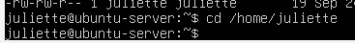
cd /root (CentOS)
ls -l
Giving permission(Same for both servers)
Command shown:
chmod +x net_dump_basic.sh
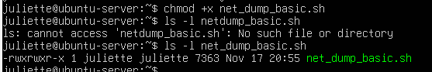
Running the script (Same for both servers)
Command shown:
./net_dump_basic.sh
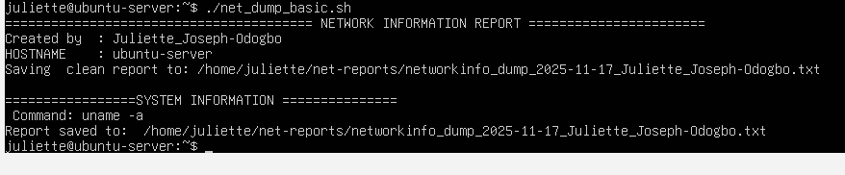
The report file being saved
Screenshot of the output:
Saving clean report to: /home/juliette/net-reports/...
— Viewing the report
Command:
cat /home/juliette/net-reports/xxxxx.txt
or
cat /root/net-reports/xxxxx.txt
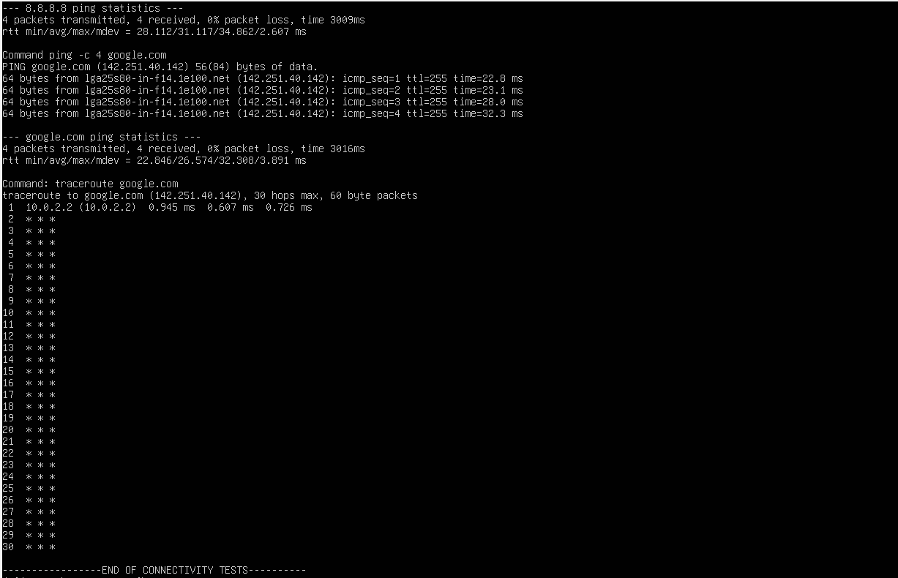

HOW TO RUN THE TROUBLESHOOTING SCRIPT (CentOS Only)
The troubleshooting script is only on CentOS and located in /root/.
Step 1 — Go to the Script Location
cd /root
ls -l
Step 2 — Give Permission
chmod +x troubleshooting_net.sh
Step 3 — Run the Script
./troubleshooting_net.sh
You will see the menu appear:
1 - Ubuntu Server fixes
2 - CentOS fixes
Enter your choice:

Sample Run Screenshots
Script in directory + permissions
ls -l
chmod +x troubleshooting_net.sh
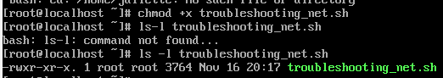
Running the script
./troubleshooting_net.sh
Menu appears.
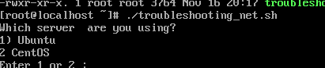
Output after selecting a troubleshooting option
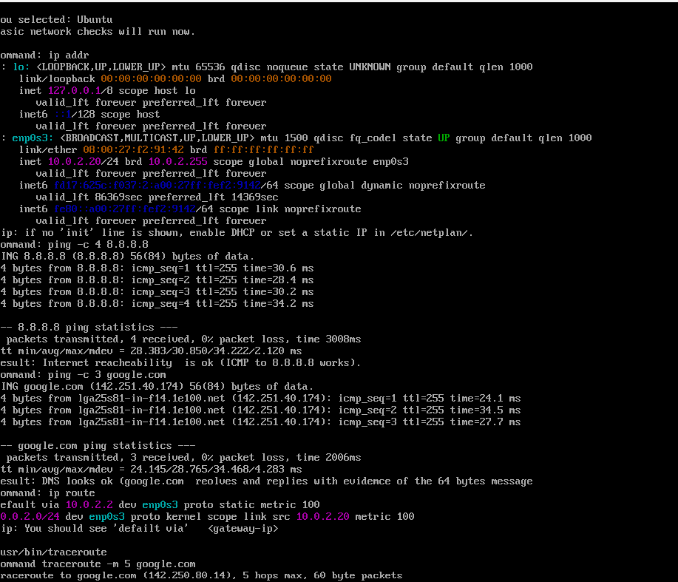

Why I Chose These Commands for My Scripts
I chose commands that work on both Ubuntu and CentOS and that show the most important network information needed when troubleshooting or documenting a server.
1. hostname – I included this because it tells me which server the report belongs to. Since I am using two virtual machines, this helps me keep the reports organized.
2. ip addr show – This command shows all IP addresses, MAC addresses, and interface status. This is one of the most important networking commands because it confirms whether the server has an IP address and if the network interface is up.
3. ip route show – I added this to display the routing table and default gateway. If the gateway is wrong or missing, the server cannot reach the internet, so this is required for basic troubleshooting.
4. cat /etc/resolv.conf – This file shows which DNS servers the system is using. DNS problems can break the internet even if the IP address is correct, so I added this to quickly verify the DNS settings.
5. ping -c 3 google.com – I included this as a simple connectivity test. If ping works, the network is working. If it does not work, it tells me where to start troubleshooting.
6. Output redirection >> – I used this so the script can collect all the results into one saved report file. This makes the script easier to run and keeps all the results in one place for submission.
7. /etc/os-release – I added this so the script can include the operating system name and version in the report. This file is standard on most Linux systems and tells me whether I am on Ubuntu or CentOS, and which version I am using. I used cat /etc/os-release in the script to capture that information

Research Paper on Why I choose to Add these commands in My Network Dump Script
Understanding Basic Linux Networking Commands and Why I Used Them
In this short paper, I explain the networking commands I used in my scripts and why they are important. I wrote two scripts during this module: a network dump script and a troubleshooting script. My goal was to make these scripts simple, organized, and helpful for someone who has little experience with Linux. I wanted the scripts to collect important information automatically, so I would not need to type many commands repeatedly.
One reason I chose commands like ip addr, ip link, and ip route is because they work on both Ubuntu and CentOS. They give the most important details about the network, such as the server’s IP address, the interfaces, and the routing table. These commands are reliable and recommended for modern Linux systems, which made them a good fit for my project.
I also included commands related to DNS and connectivity, such as cat /etc/resolv.conf, cat /etc/hosts, and ping. I picked these because DNS is one of the most common reasons a server cannot connect to the internet. The ping test helps quickly show whether the server can reach an external network. These tests made it easier to verify whether my network settings were working after switching to NAT.
Finally, for the troubleshooting script, I chose commands that a beginner can understand easily. Instead of making the user type everything manually, my script gives options. The goal was to make troubleshooting less stressful and more organized. This is especially helpful when working under time pressure or when supporting someone who is new to Linux.
Overall, these commands were chosen because they are simple, universal, and useful. They help gather all the important information needed for documentation, verification, and basic troubleshooting across both servers.

References
"The Linux ip Command." Linux Manual Pages.
https://man7.org/linux/man-pages/
"Troubleshooting Network Issues in Linux." Red Hat Documentation.
https://access.redhat.com/documentation
"DNS and Networking Basics." Ubuntu Documentation.
https://help.ubuntu.com

Two Scripts
Linux-Network-Dump-Troubleshooting/ at main · julietteagwe-cloud/Linux-Network-Dump-Troubleshooting

